**Console Login and Management**

Student Version



Huawei Technologies Co., Ltd.

|  |
| --- |
| **Copyright © Huawei Technologies Co., Ltd. 2020. All rights reserved.**  No part of this document may be reproduced or transmitted in any form or by any means without prior written consent of Huawei Technologies Co., Ltd.  **Trademarks and Permissions**  HW_POS_RBG_Vertical-150ppi.png and other Huawei trademarks are trademarks of Huawei Technologies Co., Ltd.  All other trademarks and trade names mentioned in this document are the property of their respective holders.  **Notice**  The purchased products, services and features are stipulated by the contract made between Huawei and the customer. All or part of the products, services and features described in this document may not be within the purchase scope or the usage scope. Unless otherwise specified in the contract, all statements, information, and recommendations in this document are provided "AS IS" without warranties, guarantees or representations of any kind, either express or implied.  The information in this document is subject to change without notice. Every effort has been made in the preparation of this document to ensure accuracy of the contents, but all statements, information, and recommendations in this document do not constitute a warranty of any kind, express or implied. |

|  |  |
| --- | --- |
| Huawei Technologies Co., Ltd. | |
| Address: | Huawei Industrial Base  Bantian, Longgang  Shenzhen 518129  People's Republic of China |
| Website: | <https://e.huawei.com/> |

**Huawei Certification System**

Huawei Certification follows the "platform + ecosystem" development strategy, which is a new collaborative architecture of ICT infrastructure based on "Cloud-Pipe-Terminal". Huawei has set up a complete certification system consisting of three categories: ICT infrastructure certification, platform and service certification, and ICT vertical certification. It is the only certification system that covers all ICT technical fields in the industry. Huawei offers three levels of certification: Huawei Certified ICT Associate (HCIA), Huawei Certified ICT Professional (HCIP), and Huawei Certified ICT Expert (HCIE). Huawei Certification covers all ICT fields and adapts to the industry trend of ICT convergence. With its leading talent development system and certification standards, it is committed to fostering new ICT talent in the digital era, and building a sound ICT talent ecosystem.

Huawei Certified ICT Associate-Datacom (HCIA-Datacom) is designed for Huawei's frontline engineers and anyone who want to understand Huawei's datacom products and technologies. The HCIA-Datacom certification covers routing and switching principles, basic WLAN principles, network security basics, network management and O&M basics, SDN and programmability and automation basics.

The Huawei certification system introduces the industry, fosters innovation, and imparts cutting-edge datacom knowledge.

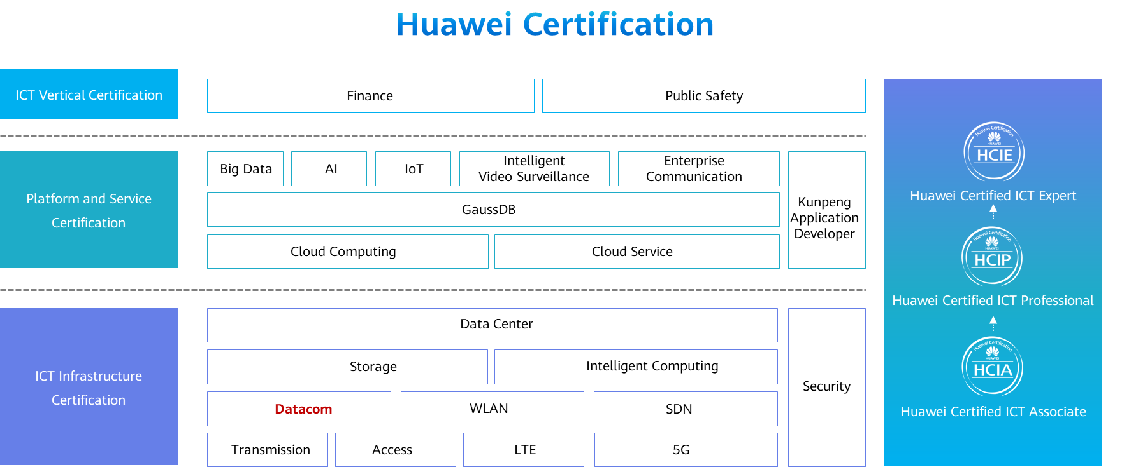

# Console Login and Management

## Background

The IT maintenance department of a company purchases S series switches, which need to be configured by network administrators. Network administrators typically need to log in to a new switch through the console port of the switch and then perform initial configurations on the switch. If you forget the Telnet or console login password, a login to the device through Telnet or the console port will fail. In this case, clear the console login password in the BootROM menu.

## Objectives

Upon completion of this exercise, you will be able to:

* Connect a terminal to a physical device.
* Change the user name and password of the console user interface.
* Clear the console login password in the BootROM menu.

## Topology

Lab Topology

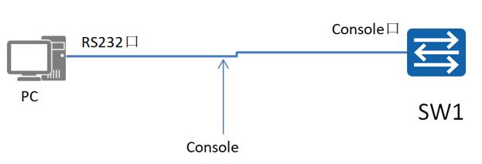

## Implementation

### Roadmap

1. Use the terminal emulation software to log in to the device through the console port of the device.
2. Change the user name and password for AAA authentication in the console user interface.
3. Clear the console login password.

### Procedure

Use the terminal emulation software to log in to the device through the console port.

#Connect the device to a PC using a console cable. The RJ45 connector connects to the device's console port, and the DB9 connector connects to the PC's serial port (COM), as shown in Figure 1-2.

Console cable connection

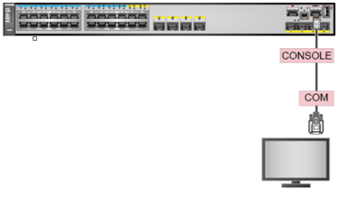



If a maintenance terminal (PC) does not have a DB9 serial port, purchase a USB-to-DB9 cable that has a DB9 male connector with nuts. Connect the DB9 female connector of the console cable to the DB9 male connector of the USB-to-DB9 cable, and then connect the USB connector to the USB port of the maintenance terminal.

#On the PC, right-click **My Computer** and choose **Properties** > **Device Manager** > **Port** to check the serial port name of the PC.

Checking the serial port name of the PC

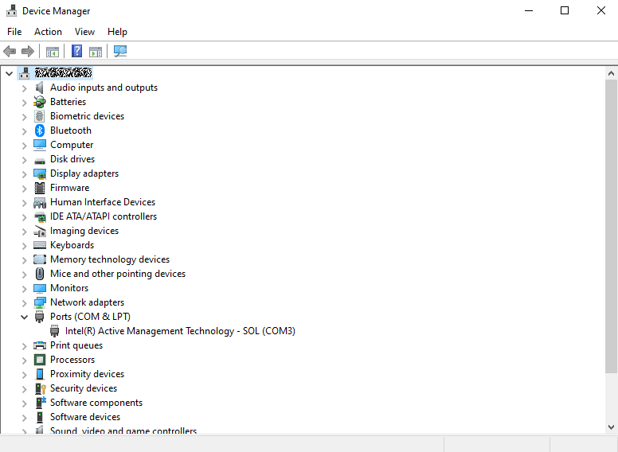

#Start the terminal emulation software on the PC. Create a connection, select the connection port, and set communication parameters. (The following uses the third-party software PuTTY as an example.)

1. Set session options.

PuTTY session options

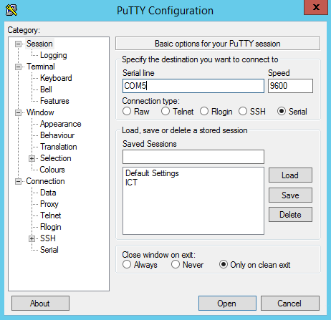

1. Set keyboard properties.

PuTTY keyboard settings

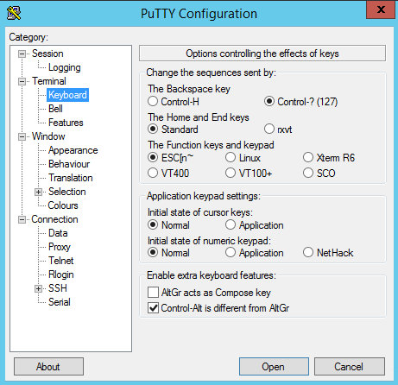

1. Set the connection port and communication parameters.

Ensure that the communication parameters you set in the terminal emulation software are consistent with the default parameter settings of the device's console port. The default settings are as follows: 9600 bit/s baud rate, 8 data bits, 1 stop bit, no parity check, and no flow control.

Setting PuTTY serial port connection parameters

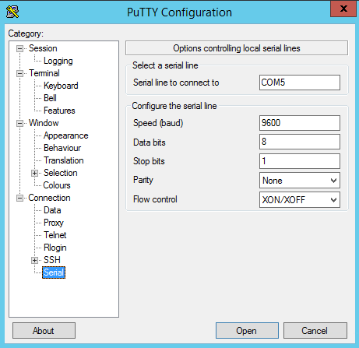

#The default setting of Huawei S series switches is that console login does not require authentication. In this case, you can click **Connect** to access the system.

<Huawei>

#Change the device name to **SW1**.

Enter the user interface view **Console0**, set the console login authentication mode to **password**, and set the password to **huawei123**.

#Log in to the device through the console port again. During the login, the system prompts you to enter the password. Enter the correct password **huawei123** to log in.

Login authentication

Password:

<Huawei>

Enter the user interface view **Console0** again, set the console login authentication mode to **aaa**, and configure the user name and password for console login in the AAA view. In this example, the user name is **huawei** and the password is **huawei123**.

#Log in to the device through the console port again. During the login, the system prompts you to enter the user name and password. Enter the correct user name **huawei** and password **huawei123** to log in.

Login authentication

Username:huawei

Password:

<SW1>

Clear the console login password.

#During device startup, the device loads the BootROM program and then the system software. When the following information is displayed, press **Ctrl+B** or **Ctrl+E** within three seconds to enter the BootROM menu.

Press Ctrl+B or Ctrl+E to enter BootROM menu : 2

password: //Enter the BootROM password.

The BootROM password of Huawei S series switches is **Admin@huawei.com**.

In V200R003C01 and earlier versions, the default BootROM password of AR series routers is **huawei**. In V200R005C00 and later versions, the default BootROM password is **Admin@huawei**.

The default BootROM password of wireless ACs is **admin@huawei.com**.

#In the BootROM menu, enter 7 to clear the console login password.

BootROM MENU

1. Boot with default mode

2. Enter serial submenu

3. Enter startup submenu

4. Enter ethernet submenu

5. Enter filesystem submenu

6. Enter password submenu

7. Clear password for console user

8. Reboot

(Press Ctrl+E to enter diag menu)

Enter your choice(1-8): 7

Note: Clear password for console user? Yes or No(Y/N): y

Clear password for console user successfully. Choose "1" to boot, then set a new password.

Note: Do not choose "8. Reboot" or power off the device, otherwise this operation will not take effect.



After the console login password is deleted, start the device using **1. Boot with default mode** in the BootROM menu. Do not select **8. Reboot** or power off the device; otherwise, the configuration becomes ineffective.

Clearing the console login password sets the authentication mode for console login to non-authentication. After the device restarts, you can directly log in to the device without entering the user name and password. To ensure console port security, it is recommended that you change the authentication mode for console login to AAA authentication after logging in to the device.